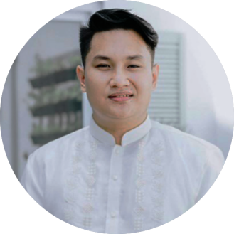

FRANCLIN JAMES LIM
—— Video Editor——

Birthday: July 10, 1994
Mobile: +63(998)383-2238
E-mail: devfranclinjames@gmail.com
Living place: Cebu, Philippines
Website: frvnc.vercel.app
CONTACT
EDUCATION
PremierePro
AfterEffects
Photoshop
DaVinci
SKILLS
- Visual storyteller
- Ability to capture authentic moments through a lens.
- Specializing in commercial videography and street photography
- Ability to render digital media with timely precision.
TECH STACK
EnfraUSA Inc. | Cebu
Web graphic Design & SEO Specialist
2017-Present

Weddings & Events | Cebu
Freelancer
2018-2024

Starlight Pictures | Lapu-Lapu, Cebu
Cameraman & Editor
2018-2019

IPM-CDC | Bacolod, Negros
IT Staff/Graphics Media Coordinator
2015-2016

ABS-CBN | Bacolod, Negros
Multimedia FLOOR director/Multimedia editor Intern
2015-2016

CSA-B Jr. Graphics Designer | Bacolod, Negros Multimedia editor Intern
2015-2015

EXPERIENCE
Colegio San Agusin | Bacolod, Ph
Information technology, Bachelor of science 2012-2016
Integrates information systems and management with digital multimedia production. Studies emphasize interactive media design, rich internet applications, 3D visualization, digital audio/video engineering, and the network architectures required for high-fidelity content distribution. Prepares graduates for roles in media technology, creative development, and interactive systems architecture.
Highly motivated Creative Design Artist with extensive customer service and professional photo/video experience.

Proven track record of Wedding and Corporate Events. Improving by experience and elevating career profile with target market.

About me

